Week 4 Integration Report
Student Information
- Name: Sayush Maharjan, Harsha Sri
Repository URL: https://github.com/sayushmaharjan/CS-5588/tree/main/week-4
https://github.com/Harsha-Sri24/DataScienceCapstone/tree/main/week-4

1. Project Overview
Brief Description:
WeatherTwin is a GenAI-powered climate assistant that delivers personalized, context-aware weather insights. By combining large language models with retrieval-augmented generation, it translates complex weather and climate data into clear, actionable guidance tailored to a user’s location, timing, and needs. Grounded in historical records and trusted sources, it highlights unusual or risky conditions and offers transparent, evidence-based explanations, helping users plan, assess risk, and make climate-informed decisions. Essentially, it acts as a “personal weather twin” that aligns real-time forecasts with long-term context.

1. Module Placement in Capstone Architecture
The Weather AI module is integrated into the capstone system as follows:
- Upstream inputs:
  - Live weather data from OpenWeather API
  - Historical temperature and humidity CSV datasets (2021–2026)
- Responsibilities:
  - Fetch and process 24-hour live forecast data
  - Compute historical monthly averages
  - Compare live conditions to historical baselines
  - Provide natural-language query responses
  - Log all user interactions
- Downstream outputs:
  - Visual dashboard (temperature, humidity, wind graphs)
  - Evidence-backed query responses
  - Structured event logs for monitoring and evaluation

2. Supported User Workflow
- User selects a city from the dashboard.
- System retrieves live weather and 24-hour forecast data.
- Historical climate data is loaded and compared to current conditions.
- User submits a natural-language weather question.
- System generates an evidence-backed response.
- Interaction is logged for monitoring and evaluation.

3. Application Interface Screenshot
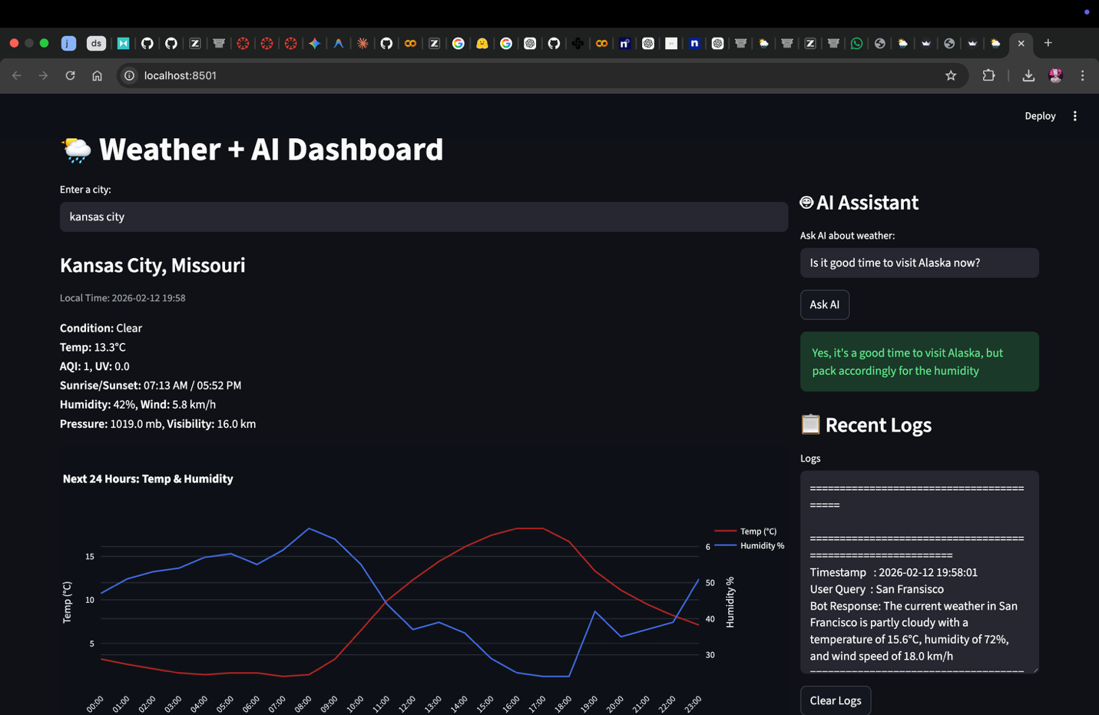

4. Logging
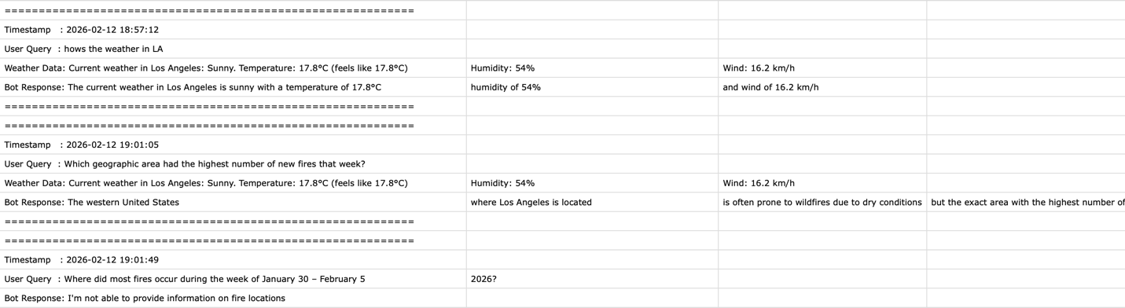

5. Architecture Diagram
System Architecture:
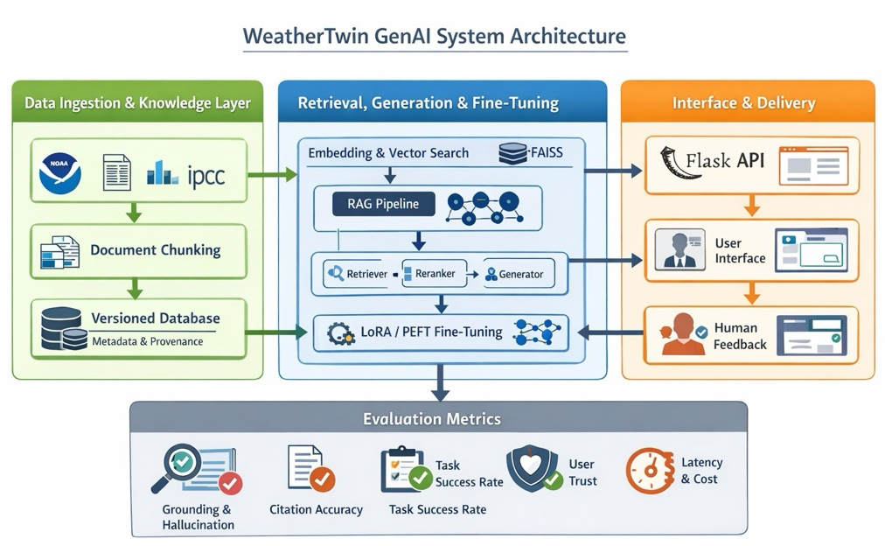

6. Production Failure Scenario and Mitigation
Scenario:
- The Weather API is temporarily unavailable or returns an error.
Impact:
- Users cannot retrieve current weather information, leading to incomplete or inaccurate responses.
- Confidence in the AI system may decrease.
Mitigation:
- Detect API status codes and handle non-200 responses.
- Display a warning banner in the dashboard when live data is unavailable.
- Fall back to cached recent forecast data for continuity.
- Log failure_flag=True for monitoring and future analysis.

